LAB 3
Conditionals, Loops, and Lists
PART 1 grade_checker.py
#Input a numeric grade from (0-100)
while True:
grade = int(input("what is your number from (0-100)?"))

if grade < 0 or grade > 100:
print("Error: Please enter a valid grade between 0 and 100.")
continue
else:
if grade >= 90:
letter_grade = "A"
elif grade >= 80:
letter_grade = "B"
elif grade >= 70:
letter_grade = "C"
elif grade >= 60:
letter_grade = "D"
else:
letter_grade = "F"
print(f"Your grade is: {letter_grade}")
message = "Congratulations, you passed the test!" if letter_grade in ("A","B","C") else "try again"
print(message)

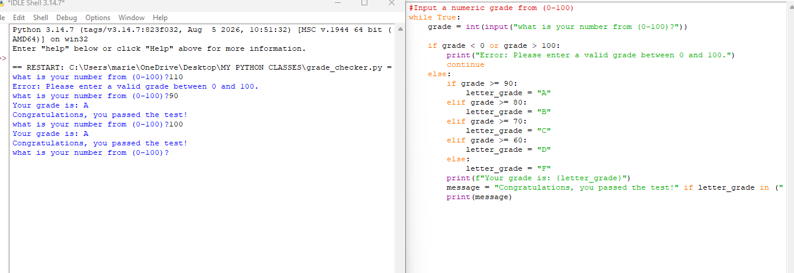

total = 0
for number in range(1,51):
if number % 2 == 0:
total += number
else:
continue
print("the sum of even numbers from 1 to 50 is", total)

total = 0
number = 1
while number < 51:
if number % 2 == 0:
total += number
number += 1
else:
number += 1
continue
print("the sum of even numbers from 1 to 50 is", total)

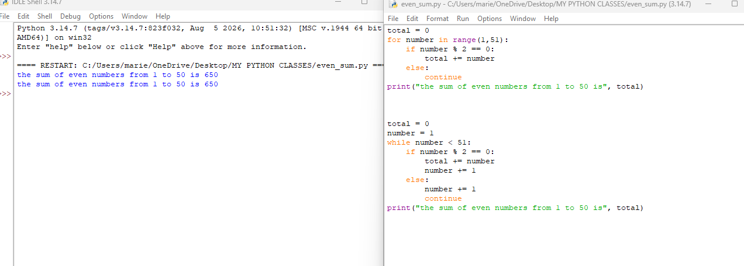
PART 2 list_operations.py
Number1 = input("what is first number? ")
Number2 = input("what is second number? ")
Number3 = input("what is third number? ")
Number4 = input("what is fourth number? ")
Number5 = input("what is fifth number? ")
my_list = []

my_list.append(Number1)
my_list.append(Number2)
my_list.append(Number3)
my_list.append(Number4)
my_list.append(Number5)

print(sorted(my_list))

sortedlist = my_list[:]
sortedlist.sort()
print(sortedlist)

NewNumber = sortedlist[:]
Number6 = input("what is your extra number? ")
NewNumber.append(Number6)
print(NewNumber)

deletedlist = NewNumber[:]
del deletedlist[0]
print(deletedlist)

reversedlist = deletedlist[:]
reversedlist.reverse()
print(reversedlist)

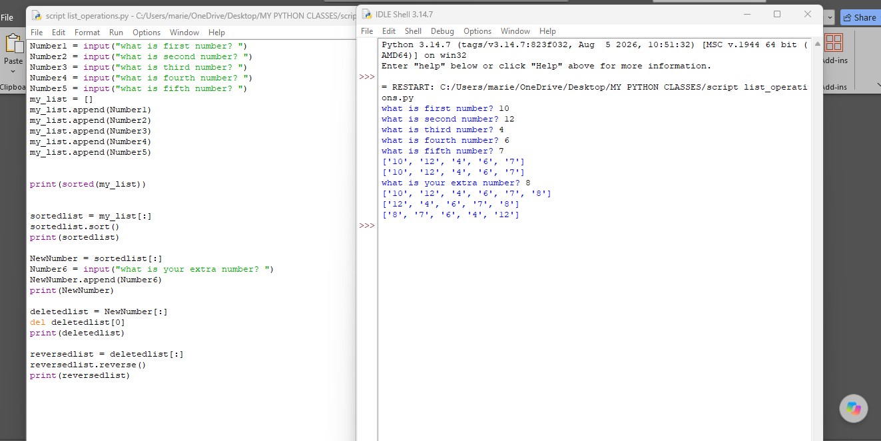

bubble_sort_demo.py
mylist = [64,24,12,22,11]
sorting = True

while sorting == True:
sorting = False
for i in range(len(mylist)):

if i + 1 == len(mylist):
continue
else:
if mylist[i]>mylist[i+1]:
mylist[i], mylist[i+1] = mylist[i+1], mylist[i]
sorting = True
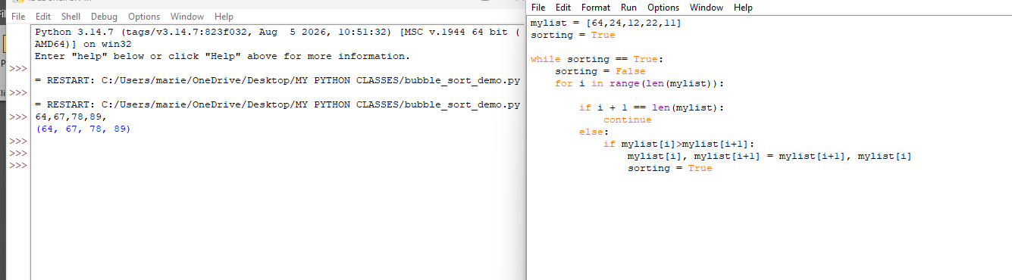

Part 3: Logic and Bitwise Operations

UserInput = input("Pick a number 1 or 0" )

AndStatement = UserInput and UserInput

OrStatement = UserInput or UserInput

NotStatement = not UserInput

print(AndStatement)
print(OrStatement)
print(NotStatement)

FirstNumber = 5
SecondNumber = 3

AndBit = FirstNumber & SecondNumber
OrBit = FirstNumber | SecondNumber
XorBit = FirstNumber ^ SecondNumber
NegBit1 = ~FirstNumber
NegBit2 = ~SecondNumber
RightBit1 = FirstNumber << 1
LeftBit1 = FirstNumber >> 1
RightBit2 = SecondNumber << 1
LeftBit2 = SecondNumber >> 1

print(AndBit)
print(OrBit)
print(XorBit)
print(NegBit1)
print(NegBit2)
print(RightBit1)
print(LeftBit1)
print(RightBit2)
print(LeftBit2)
print(mylist)
